STORIES OF CHANGE - CELEBRATING TEN YEARS OF RECOVERY CYMRU

An impact report examining the value of recovery for Recovery Cymru’s members, and ideas for Recovery Cymru’s development for the next ten years

Abigail Tweed - Director, Milestone Tweed

September 2020

CONTENTS

1 INTRODUCTION 4
2 SUMMARY OF INSIGHTS 5
3 STORIES OF CHANGE – HOW DO RECOVERY CYMRU’S MEMBERS LIVES CHANGE DURING RECOVERY? 9
3.1 Members’ increased health and wellbeing 9
3.2 Building recovery capital 11
3.3 Employment 12
4 STORIES OF CHANGE – HOW DOES RECOVERY CYMRU SUPPORT THEIR MEMBERS’ RECOVERY? 14
4.1 RC’s approach and the recovery community 14
4.1.1 RC’s members 15
4.1.2 Peer support 16
4.1.3 Environment 17
4.2 Learning – content groups 18
4.3 Support and social groups 19
4.4 Welfare checks 20
5 HOW CAN RECOVERY CYMRU DEVELOP? - WHAT DO RECOVERY CYMRU MEMBERS AND STAFF THINK RECOVERY CYMRU COULD DO MORE OF OR LESS OF? AND WHAT IS RECOVERY CYMRU’s ROLE IN THE NEXT 10 YEARS? 21
5.1 Growth 21
5.1.1 Digital growth 22
5.1.2 Geographical growth 23
5.1.3 The model 23
5.1.4 Replication 23
5.1.5 Visibility and marketing 23
5.1.6 Programmes and groups 24
5.1.7 Outreach and education 24
5.1.8 Space 24
5.1.9 Volunteering 25
5.2 Resources – funding and developing organisational sustainability 25
5.3 Collaborative working 26
5.4 RC’s role 27
6 THE VALUE OF RECOVERY 28
6.1 Financial proxies for recovery 28
6.2 Financial proxies for RC member outcomes 29
6.3 Financial costs of addiction and substance misuse 32
7 INSIGHTS FROM MEMBERS ABOUT RC’s ACTIVITIES AND PROVISION DURING COVID-19 34
8 CONCLUSION 36
8.1 Recommendations 37
APPENDIX – METHODOLOGY 39

1 INTRODUCTION

Milestone Tweed were commissioned by the Lloyds Foundation Enhance programme in January 2020 to deliver impact and evaluation work to support Recovery Cymru’s strategic planning and business plan and mark their 10-year anniversary. It is being delivered by Abigail Tweed Director of Milestone Tweed, a Lloyds Foundation Enhance consultant.

This report provides an analysis of the qualitative data collected from the Recovery Cymru (RC) community to provide the stories of change and ideas for the development of the organisation over the next ten years. These stories of change and ideas are a result of the discussions with RC members, volunteers and staff. Two facilitated focus groups, one with RC members and one with RC staff, in depth interviews with members and staff members took place in June and July 2020. In total, we spoke with twenty-two Recovery Cymru (RC) members, volunteers and staff. These discussions were all held virtually, either by Zoom or on the phone due to the Covid-19 pandemic and lockdown restrictions. Discussions were as non-directive as possible, based on the ORID method with the aim of understanding the experience of recovery and the work of RC from members’ point of view.

For context, it is important to note that RC is a peer led, mutual aid recovery community and most RC staff and volunteers are also RC members who have personal lived experience of recovery.

The discussions also picked up comments about RC’s work during the Covid-19 pandemic. Much of RC’s work moved online at the onset of lockdown in 2020. These comments are summarised in section seven, page 34.

Following an analysis of the data collected, themes have emerged from the data showing the changes in their lives which people reported as a result of their engagement with RC. Ideas about the development of the organisation have also emerged thematically from the data. Please see the Appendix, page 39, for further information on the methodologies used to collect and analyse the data.

2 SUMMARY OF INSIGHTS

Milestone Tweed were commissioned by the Lloyds Foundation Enhance programme in January 2020 to deliver impact and evaluation work to support Recovery Cymru’s strategic planning and business plan and mark their 10-year anniversary. In total, we spoke with twenty-two Recovery Cymru (RC) members, volunteers and staff in discussions and focus groups to understand their experience of recovery and the work of RC from the members’ point of view.

How do Recovery Cymru’s members lives change during recovery?
The changes can be categorised in three main themes, with some overlapping elements:
- Members’ increased health and wellbeing
- Building recovery capital
- Employment
Many of the changes were highly significant – life saving, life altering and life defining changes. Most members felt that their recovery was strongly attributed to the support from RC.

How does Recovery Cymru support their members recovery?
A consistent and dominant theme emerged – members found the approach more than the recovery groups and activities themselves, as the most helpful and critical element in their recovery. The essence of this non-prescriptive approach is that members are in a highly supportive, positive environment, where they feel safe, accepted and valued within their recovery family. They talked about a sense of belonging and living as a part of an inspiring, joyful family or community where everyone is invested in healing, and working towards a balanced and empowered life.
The RC approach has a number of component parts which are essential for the approach to work:
- The members themselves
- The peer support
- The environment
The variety of groups and activities on offer by RC were seen as useful and generally good by the members reflecting the different interests and activities enjoyed by members and the stages that members are at in their recovery journey. One to one support is highly valued by RC members. Particularly during lockdown due to the Covid-19 pandemic, this personal support was reported by a number of members as a lifeline and was hugely appreciated. RC volunteers and staff often contact members to check on their welfare, particularly if the member hasn’t been in contact for a while or has requested extra support.

How can Recovery Cymru develop - what do Recovery Cymru members and staff think Recovery Cymru could do more of or less of ? And what is Recovery Cymru’s role in the next 10 years?
The most prominent emerging theme was about RC’s growth. Many people felt that the next ten years could be a time of positive growth and expansion for the organisation. There were a number of areas for growth put forward by members, which are detailed below:
- Digital growth - continue and develop RC’s digital services following lockdown
- Geographical growth - go back to RC’s roots and vision as a Wales-wide national organisation, test the market in other areas of Wales
- The model - be confident and consistent in the approach ensuring quality
- Replication - explore the creation of a peer-based framework, scalable blueprint and franchised satellites
- Visibility and marketing - do further work to promote RC and peer support
- Programmes and groups - review programmes and activities, their timing, content and platforms
- Outreach and education - consider more education and outreach work to counter stigma
- Space - find more physical space to support activities
- Volunteering - develop the volunteer programme and create more roles for volunteers

A growth strategy needs resources. It was felt that more attention needs to be paid to business development, developing income streams and long-term sustainability to enable growth. To enable a more client-centred approach throughout people’s recovery journey, more seamless collaboration with current partners and further collaboration and networking with other potential partners was suggested.
RC has a clear role providing peer recovery support. There is enough current need and anticipated need in future for RC to carry on with the valuable work - RC needs to keep on doing more of the same. A strategic vision for growth for RC for the next ten years needs to be discussed and planned.

The value of recovery
When looking at the value of recovery to RC’s members, it is useful to consider the financial costs and implications of addiction and recovery. Indications of financial costs and benefits are often useful to help funders and commissioners understand the impact of their funding decisions. These can support them to increase funding where they have tangible evidence of the difference they are making in people’s lives. There is evidence to show that there is a positive cost benefit to providing drug and alcohol treatment. Wherever possible, financial proxies have been matched to the individual outcomes reported by RC members to give indicative financial values of these outcomes, see table 6.2, page 29.

Costs of addiction and substance misuse have also been identified to indicate the financial implications of these issues to society, see table 6.3, page 32.

Insights from Members about Recovery Cymru’s activities and provision during Covid-19
People talked about the difficulties in staying sober in lockdown. For those shielding due to health issues, isolation and loneliness was particularly prevalent. There were examples of exceptional support given by RC and members’ friends and family to make sure members felt safe and supported during the lockdown. The success of online support and the speed with which it was established was a brilliant example of the flexibility and adaptability of RC. It led some members to encourage a broader mindset about development and growth for the future of the organisation with less limits on ambitions.

Conclusion
There is ambition from RC’s members, volunteers and staff for the organisation to develop and grow. Members have benefitted hugely from their membership of the organisation and want this opportunity to be available to as many people as possible. They see a great and growing need for RC’s services. The need for peer-led mutual aid self-help organisations to partner with harm reduction, medical treatment, mental health and prevention services is matched by the ambition for growth of RC’s members. Understanding the gaps in in peer-led recovery across Wales and identifying potential partners to uncover the opportunities for RC’s growth is a recommended next step towards developing a model and system for treatment in Wales, which equally values peer-led recovery communities and mutual aid in recovery.

Within the discussions with RC members, all RC members shared their heartfelt gratitude to RC for the support they have received from RC and the changes they had been able to make in their lives as a result of that support.

Recommendations for consideration by RC are included in section 8.1, page 37.

3 STORIES OF CHANGE – HOW DO RECOVERY CYMRU’S MEMBERS LIVES CHANGE DURING RECOVERY?

There were many stories of how Recovery Cymru’s members’ lives had changed since they joined Recovery Cymru (RC). Many of the changes were highly significant – life saving, life altering and life defining changes. Many members commented on the role of RC within their recovery. Of those members, who commented on this, most members strongly attributed their recovery to the support from RC. Some felt their recovery was wholly attributable to RC and the majority felt it was an equal partnership between themselves and RC, working together towards recovery.

“100% my recovery is due to Recovery Cymru - without going there I dread to think where I would be. It saved me.”

“I know that I wouldn’t be where I am today if it wasn’t for RC.”

“Maybe 50 % of my recovery is due to Recovery Cymru and 50% due to my work. They gave me the confidence to be able to change. I know that it’s taken a lot of strength myself. It [RC] gives you the extra support so you don’t feel on your own.”

“Being in RC has been the backbone of my recovery.”

RC members, volunteers and staff commented on the changes they experienced during recovery. These changes can be categorised in three main themes, with some overlapping elements: Members’ increased health and wellbeing, building recovery capital and employment.

3.1 Members’ increased health and wellbeing

Members talked about how being a member of RC and attending the activities kept them healthy, improving both their physical and mental health. Members felt that RC helped them to be more stable, kept them sober and away from alcohol or other substances and helped them to maintain the positive changes they were making in their lives. Taking part in RC activities whether as a member, volunteer or staff member gives members purpose in their lives. They reported that they were doing something worthwhile.

They talked about having a better diet and better sleep. Reports of reduced anxiety, feeling more peaceful and with increased ability to leave the house indicated better mental health for members, as did the reports of a happier, more balanced life. Increased confidence and self-esteem were highly reported by members.
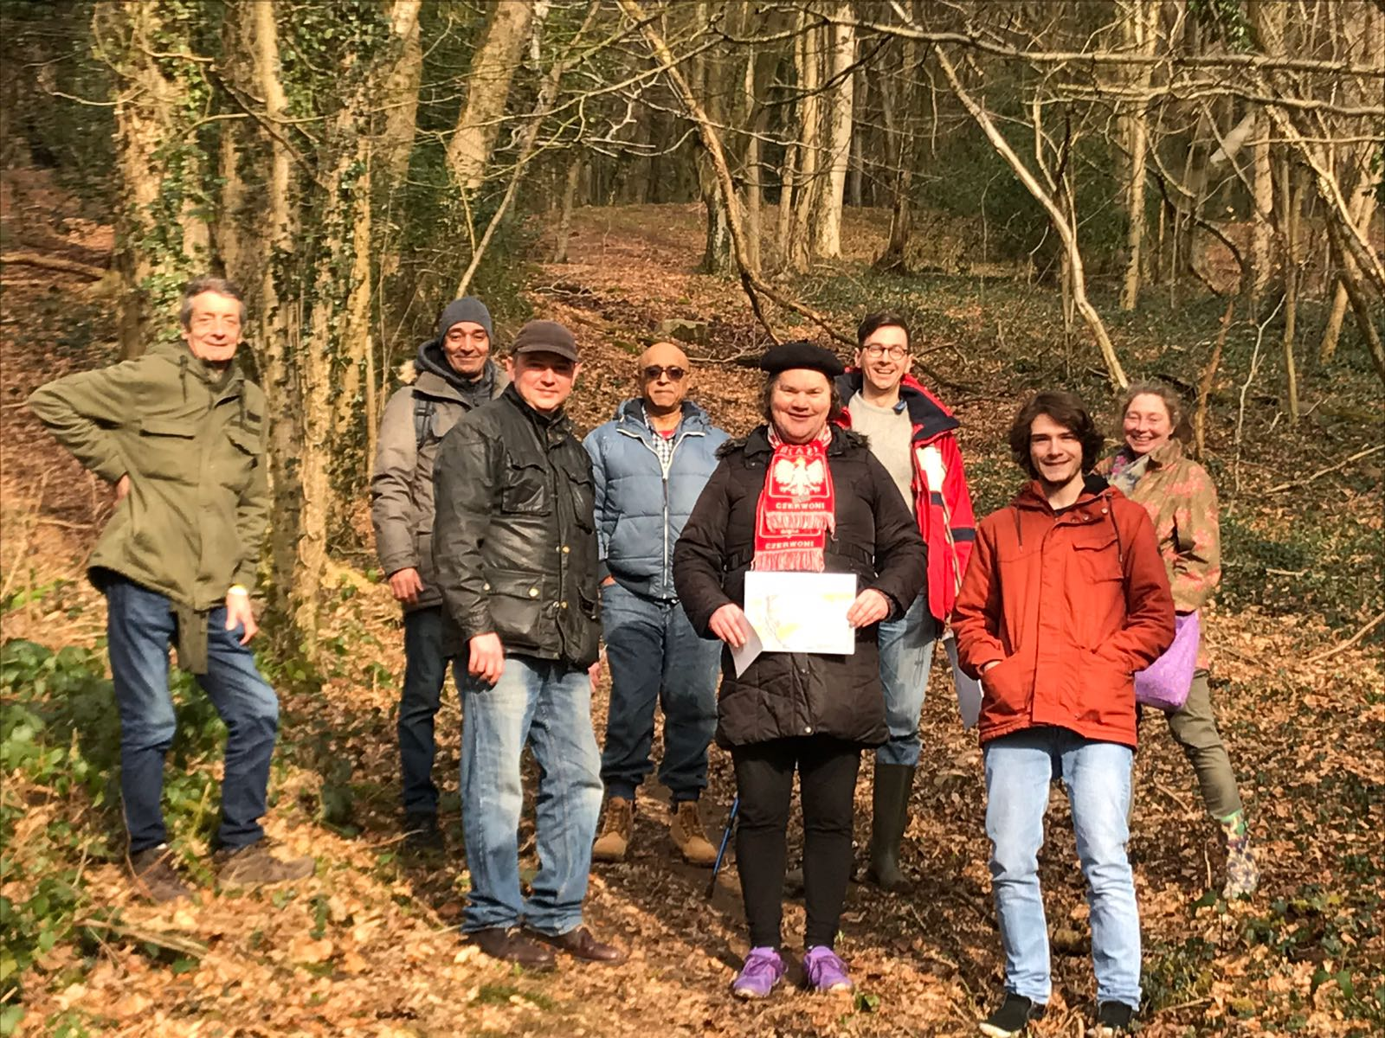
“They’ve helped me so much. I’m more confident. It’s really good mentally and physically. You’ve got all these people who actually care! It does feel like a family, it is really nice. I’ve had a volunteer phone me up during lockdown. It’s so good. Like wow. It’s been brilliant.”

Some members gained confidence through gaining new skills for example, in using psychological techniques such as mindfulness to alter low mood. The recognition of their increased skills by others also increased self-esteem.

Many of the reported changes for members were significant with some accounts of long-lasting positive changes to their mindset, such as becoming more tolerant, resilient and compassionate. People talked about learning to challenge themselves and face the things you don’t like to enable psychological growth and wellbeing. One member talked about RC and the recovery community ‘holding a mirror up to you’ and ‘calling you out on your delusions and deceptions’.

3.2 Building recovery capital

Recovery capital is the total resources that a person has available to find and maintain their recovery. RC members talked openly about the resources they felt they now had and were continuing to build in their lives. They talked about their personal recovery capital: having better health and wellbeing as mentioned previously, and other elements in their lives such as better living accommodation, better finances, skills, self-esteem, confidence and purpose. Increased independence and responsibility, ‘standing on your own two feet’ was seen as an important development by members.

“It is an organisation that treasures recovery and treats it like a valuable asset that enriches our lives and society. Its philosophy is that we can have a joyful life without alcohol.”

Family and social recovery capital were often mentioned by RC members. Prior to their lives in recovery members talked about the loneliness, isolation and lack of social networks dominating their lives. They gained new friendships as a result of joining RC, relieved loneliness and isolation, and, gained support through the recovery community. Members also shared that they had better family relationships and that they had learnt to value their relationships more as a part of their recovery.

“I’ve got no support network, no family. I know that I can always go to RC and they’re going to listen and give me some really good advice. There’s a massive weight off me as I’m not alone anymore.”

“Everything has changed for me. My relationship with my daughter and family and my social networks have improved. I really value things now. I put value on true friendships.”

People talked about reconnecting with people and organisations connected to areas of their life that they had previously enjoyed such as: book clubs, exercise and leisure activities and increasing cultural capital by reconnecting with church groups.

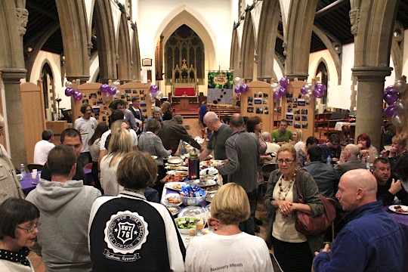

3.3 Employment

Within the recovery community at RC some members are employed, some are receiving benefits, many volunteer and a number of the members go on to volunteer with RC and then become employed by RC. Within the discussions with members, many recognised the importance of work to aid independence and responsibility, stability and health and wellbeing. A number of working members highly valued the support they received from RC which keeps them in work, supporting their employment. For example, knowing that they can access a group outside work or virtually during a lunchbreak means they can balance their recovery with their employment.

“I have had amazing support from colleagues in RC when I had a wobble in my recovery. They kept me in work otherwise I would have gone off sick. RC has given me the confidence to go back to work.”

Members talked about the skills they had gained within the recovery groups and activities as being hugely beneficial to their employment prospects with members talking about having got jobs due to being a member of RC.

“I’ve got another job as a support worker. The experience with RC helped me get the job. Being exposed to that working environment was useful.”

4 STORIES OF CHANGE – HOW DOES RECOVERY CYMRU SUPPORT THEIR MEMBERS’ RECOVERY?

RC members, volunteers and staff talked about the myriad ways in which RC supports members’ recovery.

4.1 RC’s approach and the recovery community

A consistent and dominant theme emerged when members talked about how RC supported their recovery. Members talked about the approach and ‘way of working’ or ‘how RC supports its members’ more than the recovery groups and activities themselves, as the most helpful and critical element in their recovery. This theme, therefore, describes the RC approach which as a peer-led, mutual aid organisation focusses heavily on the recovery community.

The essence of this non-prescriptive approach is that members are in a highly supportive, positive environment, where they feel safe, accepted and valued within their recovery family. They talked about a sense of belonging and living as a part of an inspiring, joyful family or community, where everyone is invested in healing, and working towards a balanced and empowered life.

“RC is not prescriptive. There is not one way to do this. RC are clear that your journey is as unique as you.”

“People start out thinking recovery is a compromise – it’s fun.”

The RC approach has a number of component parts which are essential for the approach to work: the members themselves, the peer support and the environment.

4.1.1 RC’s members
The RC members are the essential elements that build up the recovery community.

Members shared their feelings of being trusted, not being judged, being there for others, of being challenged to grow, of being hopeful, valuing people’s feelings and emotional lives and being human. Compassionate listening is a valued and crucial part of the approach. Members talked about RC being outstanding at listening.

“There is nobody you can’t talk to. Everybody is available. Everyone is valued. We have involvement and inclusion throughout the organisation. RC is special because of the staff and culture not the model.”

Many members talked about the other members and how their openness and honesty to share their experiences in recovery had helped them most in recovery. Having connections with other members, noticing their fellow members’ improvements, challenges and the similarities in their journeys was therapeutic for the members. They were humbled hearing others stories. Having people around, who have similar problems and issues is important for members’ recovery. The diversity of members’ backgrounds and experiences and hearing the many different routes to recovery was an interesting feature of the community for many members.

“I have been shocked by the intelligence and friendliness of the members. Also, there are insightful minds there. I’ve learnt - don’t judge a book by its cover. There are brilliant people and minds at RC.”

4.1.2 Peer support
The awareness that all members, volunteers and staff have lived experience of recovery is fundamental to many members’ experience of recovery. The peer element, ‘experts by experience’ with everyone around being able to personally relate to experiences of recovery, is in many members’ experience the central feature of the RC approach.

“Lived experience is our capital to be used to enhance the experience of the [recovery] community.”

“The peer support model is good – our lived experience is very important as it helps members’ barriers to come down.”

4.1.3 Environment
Members commented on the welcoming, comfortable atmosphere in a nice, well decorated space with good friendly people and an open-door policy, providing the environment for this approach to flourish.

4.2 Learning – content groups

The variety of groups and activities on offer by RC were seen as useful and generally good by members, reflecting the different interests and activities enjoyed by members and the stages that members are at in their recovery journey. It was commented that all of the groups teach you something different. It was difficult to focus on any one group as being particularly beneficial. The contact with other members within the group provided the main benefits.
Many members talked about ‘Moving on in your recovery’ and the positive impact that it had. Female members highly valued the women’s group. Outdoor activities were seen as important to help members lead their lives within the wider community. There were additional suggestions for an arts and crafts group and more mindfulness and yoga.

There were some comments on timings and the ways of delivering the groups. These ideas and suggestions are detailed in section 5.1.6, page 24.

4.3 Support and social groups

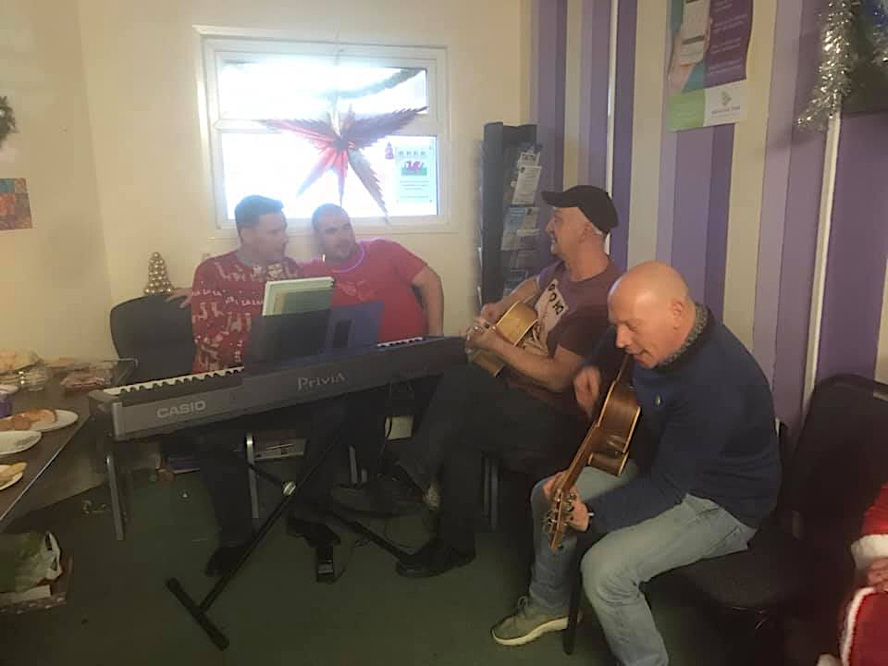
One to one support is highly valued by RC members. Particularly during lockdown due to the Covid-19 pandemic, this personal support was reported by a number of members as a lifeline and was hugely appreciated. More information about RC services and the impact during lockdown and the Covid-19 pandemic are detailed in section seven, page 34.

“The guy who supports me phoned three or four times a week when I moved home during lockdown. I was surprised and really thankful for the support.”

Social groups were mentioned by a number of members as useful to support engagement and contact between members. Mentions were made of the music sessions and the cookery social, which has now stopped, but one member remembered these sessions fondly.

4.4 Welfare checks

RC volunteers and staff often contact members to check on their welfare, particularly if the member hasn’t been in contact for a while or has requested extra support. During the lockdown members were particularly grateful for welfare checks and a number of members talked about the welfare checks as critical to keeping them on track during challenging times. More information about RC services and impact during lockdown and the Covid-19 pandemic are detailed in section seven, page 34.
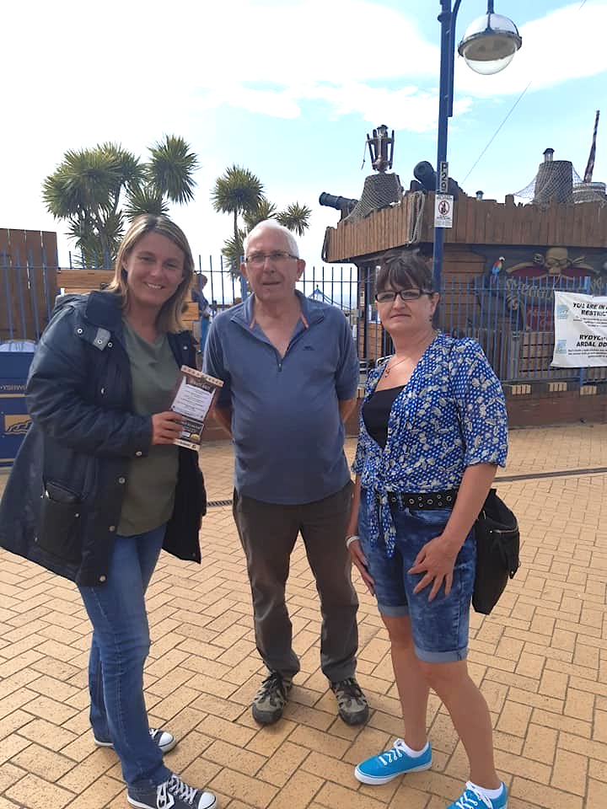

5 HOW CAN RECOVERY CYMRU DEVELOP? - WHAT DO RECOVERY CYMRU MEMBERS AND STAFF THINK RECOVERY CYMRU COULD DO MORE OF OR LESS OF? AND WHAT IS RECOVERY CYMRU’s ROLE IN THE NEXT 10 YEARS?
This section sets out the thoughts, ideas and reflections of members, staff and volunteers about the direction of travel for RC following the first ten years of operation.

All members, volunteers and staff were unhesitatingly confident and positive about the future for RC. There were a significant number of insights and ideas put forward which were due to the experience of lockdown and the Covid-19 pandemic. Everyone recognised the world had changed significantly since the onset of the pandemic and RC would need to respond to this new context in its development plans.

5.1 Growth

From analysis of the data the most prominent emerging theme was about RC’s growth. Many people felt that the next ten years could be a time of positive growth and expansion for the organisation. There were a number of areas for growth put forward which are detailed below.

Balancing growth with consolidation of current services, for example, by doing further work on clarifying the model and understanding the unique selling points of RC was mentioned by one member as an important factor, when examining options for growth. There was recognition that RC is good at being flexible and adaptive in a fast-moving environment, as shown by the swift movement to online and virtual provision and contact with members.

“We need to be more confident at saying what we can do and what we are good at. We were swift to adjust to online in Covid.”

Another member felt that growth needed to be looked at with a new mindset in light of the changes that were made to RC operations during lockdown. There was awareness that the organisation itself needs psychological flexibility to be able to grow. It was suggested that it could be useful to adopt the messages RC promotes to its members within its organisational approach to growth, for example, encouraging people to rethink the barriers to their personal development. A new more ambitious approach to RC’s vision could be examined.
“We need to be mindful of our willingness to change. We need psychological flexibility. We would never have thought we could have a good digital offering but Covid has proved we can do this successfully.”
It was felt that there will be a greater need for RC’s services due to the economic downturn and Covid-19 and, therefore, that this was the right time to be focussing on opportunities for growth. For any area of growth and development it was recommended that RC should analyse trends and demographics to meet the needs of the communities it serves.

5.1.1 Digital growth
All members, staff and volunteers felt there was room to continue to develop RC’s digital services following lockdown. A variety of options were suggested:

- Continue with virtual online groups to support working people to attend at useful times – e.g. lunchtime, weekends, after work twilight sessions and evenings
- Consider trialling hybrid mixed groups – part online and part in the room
- Lever technology to attract younger people
- Use more online resources
- Use digital technologies to grow geographically across Wales – use virtual platforms in other geographic locations across Wales to advertise and test the value in RC’s offer with less risk and cost associated with this development
- RC’s branding will need to be changed if a digital offer is continued and developed further
- Make virtual sessions smaller with less than 15 people so it is not too overwhelming for people

“I would hope they can carry on with this online after lock down. Even a mixed group with people in the room and online might work. It would allow me when I’m back in work to access this. I travel in my job and my office is over an hour away and I would be able to access this online at work.”

5.1.2 Geographical growth
People talked about RC going back to its roots and vision of being a Wales-wide national organisation. Currently RC’s commitment is to be a part of the wider recovery network across Wales and the UK. People suggested this was the time to test the market in other areas of Wales, initially digitally.

“We need to open our community to more people now that we’re online. We’re not bound by geographic locations.”

Caution was expressed by one member who felt that the current location in the Vale was perhaps not as valued as the main centre and that this issue would need consideration if further locations were established.

5.1.3 The model
Clarification of the model was suggested. There is a need to be confident and consistent in the approach, ensuring quality across all areas of the organisation. Ensuring value for money and efficiency balanced with a holistic approach was recommended.

5.1.4 Replication
It was suggested that RC could put a peer-based framework together creating a scalable blueprint. Satellites could be created to replicate RC’s work and opportunities to franchise these satellites could support growth.

5.1.5 Visibility and marketing
Many members talked about the need for RC to do more work to promote RC further and promoting peer support more generally. It was felt that there needed to be more visibility for RC, that it was too hidden for both the general public and associated networks and services. Advertising in local communities was seen as a positive development, that would help reach more people.

5.1.6 Programmes and groups
While most people felt there was a good range of programmes and activities, there was a suggestion that RC could do more.
There were a number of ideas for changes to the programmes, activities and groups. These include:
- More social activities
- More arts and crafts therapy activities
- More mindfulness and yoga
- More external groups getting out into the community - recovery is about enjoying life and feeling confident to go out
- Increase out of hours activities to support more working people to attend for example, after work on weekdays, weekend sessions, more evening sessions and late-night sessions. “This needs to looked it they [working people] are an invisible group.”
- Explore more content, look at new resources and gain fresh ideas to be more relevant and cutting edge
- Explore further issues and communities needing support, such as addictions to gambling and computer games, young people in recovery, family therapy and family support.

5.1.7 Outreach and education
A number of people would welcome more education and outreach work to counter stigma. It was felt that further work could be done in corporate workplaces on recovery, with students and staff in higher education, and in hospitals before individuals reach crisis stage. There were conflicting views about whether RC should be working with younger people in schools and colleges.

5.1.8 Space
Members like the welcoming space and talked positively about the RC building. However, many talked about the need for RC to gain more physical space to be able to welcome more people as they enter the building, have areas for quiet conversations and have room for more activities. Further space in other geographical locations was also proposed.

“The building is quite small so if you’re not in the activity there is not a lot of space to sit. Mindfulness and yoga needs space. They only have one room for an activity and a smaller room for four or five people. The building doesn’t have the space. We sit in reception until they tell us to move on. We huddle up there in a big room until they do a session. There is another room with no windows sometimes people sit there. There is no coffee room where you can sit and chat.”

5.1.9 Volunteering
Many members go on to become volunteers at RC. The additional training, skills and responsibility they gain through this progress helps them with their recovery.

“The Volunteer programme is brilliant – I was impressed with it. There is a comprehensive training programme which was really well handled and professional. There are options for what you want to do. I chose to volunteer and meet people on reception, directing them into a group. Or you can be a mentor.”

Some members talked about developing the volunteer programme and creating more roles for volunteers as a way to increase growth for the organisation. There would however need to be further work done to improve the connection between paid staff and volunteers with one member commenting:

“There is a disconnect upstairs and downstairs. They need to take a look at that. The staff lose connection with the members and the members wonder what the staff are doing. That could be improved.”

5.2 Resources – funding and developing organisational sustainability

A growth strategy needs resources. It was felt that more attention needs to be paid to business development, developing income streams and long-term sustainability to enable growth. One member suggested developing RC branded products. Another member talked about widening services within and outside Wales and developing opportunities and links with rehab centres and community services as additional income streams. One member suggested there is an opportunity to provide training for online SMART recovery volunteers. More detail about this is in the next section 5.3 Collaborative working.

5.3 Collaborative working

Being client-centred was important to members. To enable this, more seamless collaboration with current partners and further collaboration and networking with other potential partners was suggested. It was felt by one member that it could be beneficial for the current three-way partnership between RC and two other partners to be seen as one organisation by members.

“When you get people from detox one partner pitches to the detox centre for the individual to come to them first. Then people drop out as they are not ready for this particular service, they need peer support. There isn’t a client centred approach by all three partners.”

“When funding is announced the partners fight to get more money than each other. They fudge the stats and then people in recovery don’t get the money they need to support them, they fall between the cracks.”

Members recognised the gaps in services and felt more could be done collaboratively to support people on their recovery journey, where there were obvious points when people could easily struggle. For example, when people are waiting for rehab services, they need specialist support that will accept you while you are still drinking or using other substances. Taith was mentioned in this instance as a useful service. People talked about this as a critical point, with people needing swift help once they had decided to go into recovery.

“There are gaps. Logistically sometimes you have to wait. Waiting is the worst you can do for people waiting to recover.”

Suggestions for further collaborative working were put forward by members:

- Working with housing associations, for example, Cadwyn housing and Taff Housing who work with young women in a hostel environment
- Other rehabilitation services, for example, Sefton, Stroud, the Nelson Trust, Weston Supermare, Bournemouth and other rehabs around the Bristol area who are unaware of RC

5.4 RC’s role

Members and staff felt that RC has a clear role in providing peer recovery support and that there is enough current need and anticipated need in future for RC to carry on with the valuable work it is doing. Common feedback was that RC needs to keep on doing more of the same. When asked what RC’s role in the next ten years is, people often talked about growth. A strategic vision for growth for RC for the next ten years needs to be discussed and planned.

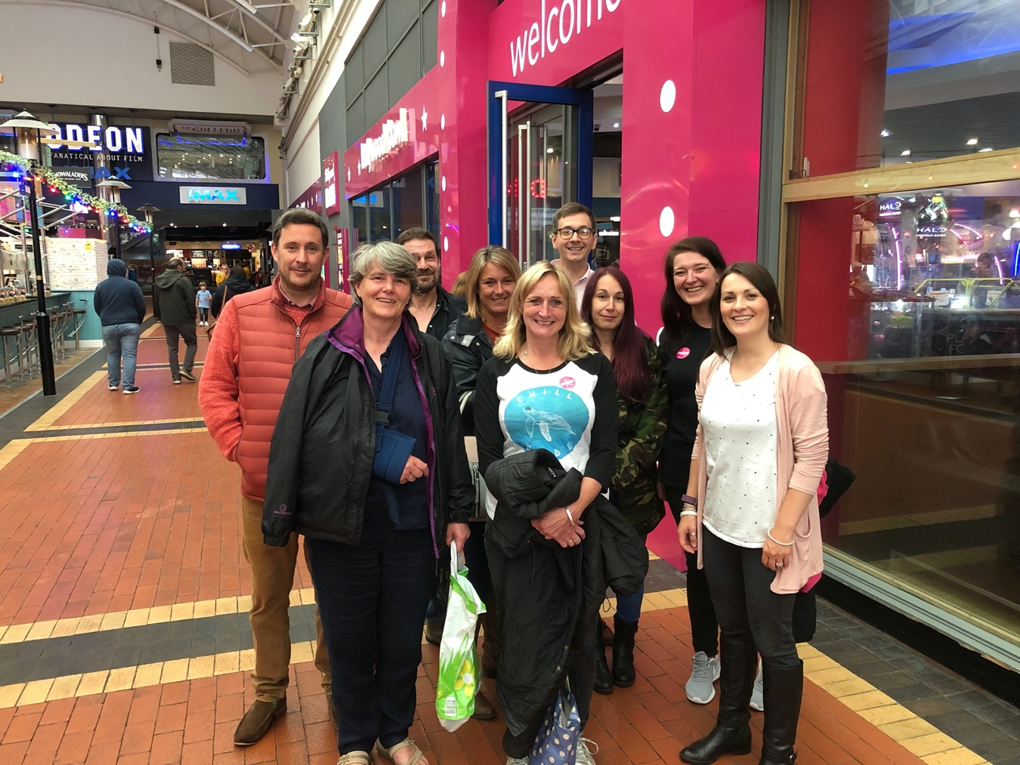

6 THE VALUE OF RECOVERY

When looking at the value of recovery to RC’s members, it is useful to consider the financial costs and implications of addiction and recovery. Addiction and substance misuse has a huge cost, both social and financial, to individuals, those closest to them and society in general. The converse is also true, recovery has huge value, social and financial, for both the individuals in recovery, those closest to them and also for society.

Indications of financial costs and benefits are often useful to help funders and commissioners understand the impact of their funding decisions. Indicative costs and benefits can support them to increase funding where they have tangible evidence of the difference they are making to people’s lives. In the table 6.2 below are some initial indicators of financial costs and benefits in relation to recovery and addiction. These can be used in communications with funders, commissioners and other stakeholders to indicate the return on their investment. To be more precise about the financial value of Recovery Cymru’s work more in-depth methodologies can be used to clarify the value gained, for example, Social Return on Investment (SROI) and Cost-Benefit Analysis (CBA). These methodologies make use of financial proxies to establish the value of the identified outcomes. Usually price is used as a proxy for the value of products and services, when there is an associated market. The definition of a financial proxy is: an approximation of value where an exact financial measure is impossible to obtain. Most of the outcomes reported by members cannot be traded in an open market or are intangible. For these a closely comparable value of a product/service is identified with a market price and these have been selected by researchers often drawing upon consultation with stakeholders. There are a number of ‘Social Value Banks’ or resources, for example, the Global Value Exchange or the HACT UK Social Value Bank Calculator which have collated financial proxies and these have been used as shown below in the table 6.2.

There is evidence to show that there is a positive cost benefit to providing drug and alcohol treatment. A 2014 report from Public Health England reported that every pound spent on drug treatment saves £2.50 in costs to society. A Cost–Benefit Analysis of Drug Treatment Services: Review of the Literature in 2000 reported a persistent finding that benefits exceed costs.

6.1 Financial proxies for recovery
RC members, staff and volunteers all gave examples of how their lives had significantly changed as a result of their membership of RC. These could be categorised into three outcome areas: increased health and wellbeing, building recovery capital and employment. The individual outcomes, reported by members, within these outcome areas are listed below in table 6.2 and alongside these, wherever it has been possible to find some, are financial proxies which have been used by other researchers and organisations, when making indications of the financial value of these outcomes.

6.2 Financial proxies for RC member outcomes

RC MEMBER OUTCOMES | FINANCIAL PROXY | ANNUAL FINANCIAL VALUE OF RECOVERY PER PERSON
Increased health and wellbeing:
Improving physical health | HACT UK Social Value for outcome: Good overall health | £20,141
Improving mental health | HACT UK Social Value for outcome: Relief from  depression/anxiety  Social Value Lab - NHS for outcome: The cost of treating someone with depression  Ffrindia SROI analysis report for outcome: Improved mental health / avoided deterioration | £36,766  £2,085  £4,919.04
Increased stability
Sobriety | HACT UK Social Value for outcome: Relief from drug/alcohol problems | £26,124
Purpose in life
Better diet
Better sleep
Reduced anxiety | HACT UK Social Value for outcome: Relief from depression/anxiety | £36,766
Increased confidence | HACT UK Social Value for outcome: High confidence | £13,080
Increased self esteem | GLOBAL VALUE EXCHANGE. Social Value for outcome: Confidence and self-esteem change in self-employed people | £2,625
Feeling peaceful
Can leave the house
Feeling happier
Gained skills | Ffrindia SROI analysis report outcome: Average of the volunteer value-games for gaining skills | £3,734.68
Mindfulness skills | PSSRU Unit costs of health care for outcome: 2hrs per week of mindfulness- based cognitive therapy over 43 weeks per year | £1,204
Improved mood
Increased tolerance
Increased resilience | HACT UK Social Value for outcome: Feel in control of life | £15,894
Increased compassion
Building recovery capital:
Better housing | HACT UK Social Value for outcome: Temporary accommodation to secure housing | £8,019
Buying a house | Intermediary Mortgage Lenders Association (IMLA) for outcome: benefits of home ownership compared to renting | £11,750
Better finances | HACT UK Social Value for outcome: Financial Comfort | £8,917
Increased independence | GLOBAL VALUE EXCHANGE. Social Value for outcome: Change in functional independence for individuals | £6,228.04
Increased responsibility
Relief from loneliness and isolation | Ffrindia SROI analysis report outcome: Reduced feelings of social loneliness  HACT UK Social Value for outcome: Reduced feelings of social loneliness | £5,580.18  £2,337
Gaining new friends | GLOBAL VALUE EXCHANGE outcome: Seeing family/friends x1/x2 a week to most days | £15,500
Better family relationships | HACT UK Social Value for outcome: Can rely on family | £6,784
Joining a club | HACT UK Social Value for outcome: Member of social group | £1,850
Joining a religious group | HACT UK Social Value for outcome: Member of social group | £1,850
Employment:
Keeping in work
Not taking sick leave
Volunteering | HACT UK Social Value for outcome: Regular volunteering | £3,249
Gaining part time work | HACT UK Social Value for outcome: Part time employment | £1,229
Gaining full time work | HACT UK Social Value for outcome: Full time employment | £14,433

6.3 Financial costs of addiction and substance misuse

It is difficult to find documented costs of addiction to individuals. However, there are many examples of the costs of addiction to society. Substance misuse can cause a wide range of harms. These include impacts on physical and mental health, unemployment, homelessness and criminal activity. It is possible that drug and alcohol-related crimes may create some of the highest costs of addiction to society, in 2010/11 Public Health England reported that drug-related crime created the highest financial cost of illicit drug use when compared with health service use and costs due to illicit drug use.

Below is a table with examples of quantified costs of addiction to society. The costs are not easily comparable as they come from a variety of sources from research and papers within the last ten years. Please click the hyperlinks on the costs per year to see the sources of the data. These examples serve as an indication of the impact of addiction on society and the associated costs.

COSTS OF ADDICTION AND SUBSTNCE MISUSE TO SOCIETY | Costs per year
The total cost to the NHS of alcohol harm is estimated to be a year. | £3.5bn
Alcohol fuelled crimes | £11.4 bn
Drug related crime | £960m
Foetal alcohol spectrum disorder (FASD) cost per year | £2bn
“Conservative” estimate of 350,000 alcohol-related ambulance callouts per year in England (not including costs associated with 999 or 111 centres). | £81.1m
Inpatient detoxification for people who misuse drugs or alcohol | £55,172 per person per year (2012/2013)
Specialist prescribing for drug misuse in a specialist drug service setting | £2,808 per person per year (2012/13)
Annual costs of consultations by an Alcohol health worker, Accident & Emergency | £86,562 (@c.30 consultations per week)
The cost of harm to 1.5 million adults who are affected by a family member’s drug use | £1.8bn
The support family members provide to a family member using drugs | Worth £750m (the cost to the NHS or local authorities if family members didn’t provide this support)
The cost spent by UK Government on drug treatment | £1.1bn

7 INSIGHTS FROM MEMBERS ABOUT RC’s ACTIVITIES AND PROVISION DURING COVID-19

The Covid-19 pandemic and the subsequent lockdown created a challenging environment for many people in recovery. The interviews and discussions for this report took place mainly in June 2020 when all of the UK was placed in lockdown. All of the participants who were interviewed as a part of this report talked about the challenges they were experiencing.

People talked about the difficulties in staying sober in lockdown.

“So many people have relapsed in lockdown. When we do come out of lockdown we will hopefully find out what the implications of lockdown were for people in recovery and I imagine there will be a massive upsurge in addiction problems. We will need more services to help.”

For a number of people they were also shielding due to health issues and isolation and loneliness was particularly prevalent for these individuals.

Some members found positive outcomes within lockdown. Some members felt that their IT skills had improved.

“Being isolated now it is good for people to reflect on themselves.”

One member had joined RC just before lockdown and had only experienced virtual online line activities.

“I live by myself and I have been able to interact with others. This brings an added dimension. The support from the groups online has been even more beneficial for me. It’s the sense of community which an isolated person isn’t going to get in real life at the moment. It has more impact in the COVID world.”

There were examples of exceptional support given by RC and members’ friends and family to make sure members felt safe and supported during the lockdown.
One member talked about the support she gained from her daughter who realised the critical importance of her mother’s contact with RC during the lockdown period.

“I’ve got one daughter, she’s not living near me. She bought me the computer at the beginning of lockdown as she was worried I wouldn’t be in contact with RC. That’s how important RC is for me and she realised the effect RC has on me.”

Another member talked about how he had been sent an unused mobile phone from the RC office when his phone, his only means of contact, during the lockdown broke.

The quality of the online provision was commented on by members, and the peer element of the RC approach has also supported the move to online groups.

“The [online] facilitators are massively supportive. It’s been pitched right. It’s a been a learning environment for us all in a virtual world. They [the facilitators] want it to succeed as they are also invested in RC. The fact that the facilitators are former members is useful. They find running through the sessions just as useful for them as individuals, as they do as professionals supporting other members.”

The success of online support and the speed with which it was established was a brilliant example of the flexibility and adaptability of RC. As discussed on page 21, it led some members to encourage a broader mindset about development and growth for the future of the organisation with less limits on their ambitions – anything is possible!

8 CONCLUSION

Members talked freely about how becoming a member of Recovery Cymru saved their lives, and continues to support them in their recovery. The uplifting stories from members about the benefits they receive due to their membership and their recovery journey are inspiring and remarkable. This positivity was particularly remarkable given that the discussions all took place within the lockdown due to Covid-19 in June 2020. This lockdown was described as particularly challenging for many people in recovery. Throughout the discussions members demonstrated how they had increased their self-awareness, empathy and resilience as result of their recovery. Their stories of change were humbling and life affirming.

The peer-led community and mutual self-help model is an essential part of recovery and needs to be an equal and valued partner in addiction services, as proposed and championed by Dr Ed Day, Home Office National Recovery Champion and Consultant in Addiction Psychiatry, Solihull Integrated Addiction Service. From his recent presentation “What does good look like after Covid-19” he asks: Have recovery-orientated systems of care finally come? He presents the model below of a treatment system which equally values peer-led recovery communities and mutual aid.

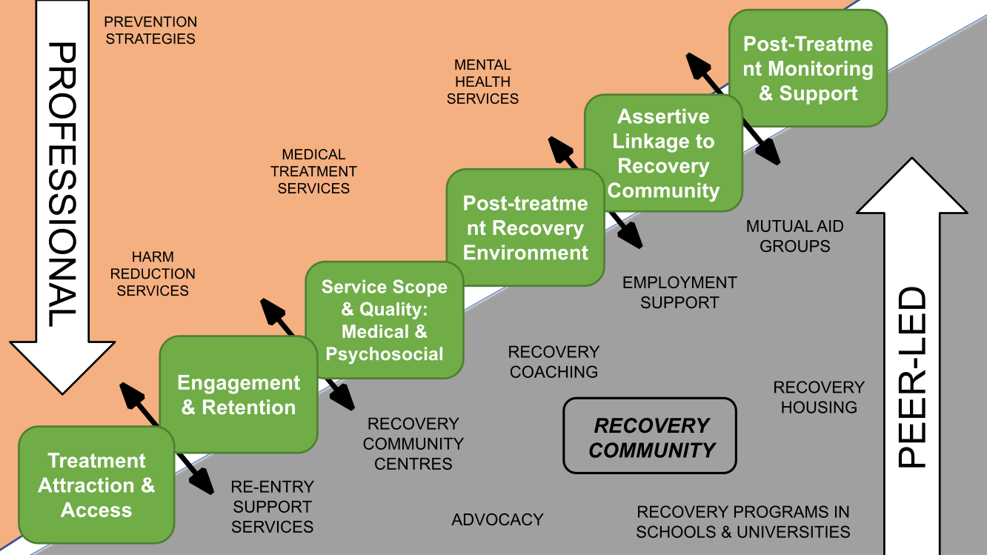

There is clearly ambition from RC’s members, volunteers and staff for the organisation to develop and grow. Members have benefitted hugely from their membership of the organisation and want this opportunity to be available to as many people as possible. They see a great and growing need for RC’s services.

The need for peer-led mutual aid self-help organisations to partner with harm reduction, medical treatment, mental health and prevention services is matched by the ambition for growth of RC’s members.

Understanding the gaps in in peer-led recovery across Wales and identifying potential partners to uncover the opportunities for RC’s growth is a recommended next step towards developing a model and system for treatment in Wales, which equally values peer-led recovery communities and mutual aid in recovery.

Within the discussions with RC members, all RC members shared their heartfelt gratitude to RC for the support they have received from RC and the changes they had been able to make in their lives as a result of that support.

8.1 Recommendations

In the process of writing this report a number of recommendations have been collated for consideration by RC.

- Review programmes and activities – timing, content and platforms
- Bring together partners and services involved in delivering recovery and alcohol and drug rehabilitation services within each geographical service location and together map an individual’s recovery journey as they engage with services to ensure the entire journey is client-centred
- Review the vision for RC – does it need to be more specific? In terms of its geography and / or service delivery?
- A discussion paper, potentially with an options appraisal about the vision for growth of RC could be presented to the Board of RC for appraisal of the options in light of the feedback from members, volunteers and staff
- Consider the suggestions put forward about digital growth on page 22, and create a digital strategy and action plan
- Trial hybrid virtual and in person groups
- Review the RC model – test it for consistency and quality across all service areas
- Gain expert advice on replication models, franchising and satellite services
- Review your marketing strategy
- Analyse trends and demographics to meet the needs of the communities you serve
- Review your programme of services and activities
- Review your outreach and engagement activities and plans
- Consider gaining more physical space to work with members
- Review your volunteering programme
- Consider gaining additional support and expertise to develop further sustainable income generation and fundraising strategies
- Review your engagement with rehabilitation services and other medical and health services. Do you need to do further engagement?
- Consider other potential partners and networks
- Create a prioritised stakeholder matrix and relevant engagement plans
- Create a ‘lessons learnt’ document summarising the learnings from the Covid-19 pandemic and lockdown so far to inform future provision
- Understand the gaps in in peer-led recovery across Wales and identify potential partners to uncover the opportunities for RC’s growth

APPENDIX – METHODOLOGY

This report is based on evidence collected either via Zoom or phone. We spoke with ten people in one-to-one discussions. All of these individuals are RC members, some were also volunteers and one was a staff member. In addition, we spoke to twelve members in focus groups. In total, we spoke with twenty-two RC members. The data sets therefore include:
- Discussions with individual RC members
- Discussions with individual RC volunteers
- Discussions with individual RC staff members
- One virtual focus group held via Zoom with seven RC members
- One virtual focus group held via Zoom with five RC staff members
Individuals were asked about their experience of engaging with RC, their reflections and insights on their experience, any actions or changes that could be made to improve their, or others’, experience of engaging with RC and their thoughts on the role of RC in the next ten years. Questions were as non-directive as possible, based on the ORID method. Approaches in grounded theory were used so that the themes genuinely emerge from the text with minimal bias and these results have been used to inform the basis of this report. Results are not intended to be fully scientific.

The ORID method is a focus group process that facilitates a structured discussion that can be used for one-to-one conversations and with small groups (up to 12 people). ORID stands for: Observation, Reflection, Insight & Decision
https://facesandvoicesofrecovery.org/blog/2019/10/08/recovery-capital-its-role-in-sustaining-recovery/
The ORID method is a focus group process that facilitates a structured discussion that can be used for one-to-one conversations and with small groups (up to 12 people). ORID stands for: Observation, Reflection, Insight & Decision

