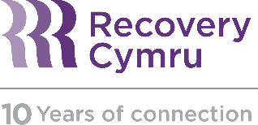 | Wellbeing in the workplace

Well-being in the workplace

Substance misuse affects individuals, families, communities and the workplace. It can affect wellbeing, health, relationships and performance. It can remain hidden for some time, and is often linked to mental wellbeing.

The Health and Safety Executive says that alcohol and drug abuse cost the UK £21 billion and £15 billion respectively. The Institute of Alcohol Studies says that 17 million working days are lost each year in the UK due to alcohol use alone; 70% of substance abusers are in full time employment.

Greater understanding about how substance misuse develops and affects individuals can help create supportive and non-judgemental organisational cultures which promote health and wellbeing, reducing stigma. It can make it easier for employees to accept and admit if they are experiencing problems if they know managers understand employees’ experiences, thus increasing confidence in approaching difficult conversations for both managers and employees.

As part of your workplace commitment to employee wellbeing, Recovery Cymru can provide a complimentary 1.5-hour awareness session including visual storytelling from members and staff alongside a Q&A session which can be tailored to your organisation.

These sessions work well as part of your employee wellbeing or awareness sessions, lunch and learn, information talks or within a conference programme. They can be delivered online via Zoom.

“Personal stories, useful hints and tips, videos of individuals”

“Really enjoyed it, useful outside of work as well”

These sessions can be complimented by the Recovery Cymru Training course: Managing substance misuse in the workplace. More details can be found here http://www.recoverycymru.org.uk/training/ or contact training@recoverycymru.org.uk

We welcome donations to the Charity in lieu of a fee.

